Minimum Entry Requirements
& Assessment of Mature Student Applicants
for the Higher Certificate and Bachelor of Engineering in Manufacturing Engineering (Apprenticeship mode)

Rev 3 May 2018
Department of Mechanical and Industrial Engineering

Introduction
This document outlines the requirements for entry onto the Higher Certificate and B Eng in Manufacturing Engineering Apprenticeship Programmes.

Included are details of the required Irish Leaving Certificate prior and subsequent to the revised Leaving Certificate grading scale (effective from the June 2017 examination).

For the purposes of consistency, QQI recommends adoption of this new grading scale by higher education and training providers of QQI validated programmes.

Also outlined below are the QQI-FET and Mature Applicant entry requirements for the programme.

Entry Requirements for Irish Leaving Certificate Applicants (From August 2017)

Applicants must have obtained a minimum of 5 O6 (pass) grades in their Leaving Certificate examination results. These subjects must include Grade O6/H7 or better in Mathematics and English or Irish.

The Leaving Certificate Applied does not meet the minimum entry requirements to Institute programmes. Holders of the LCA may gain entry following completion of a FETAC Level 5/6 Award.

Entry Requirements for Irish Leaving Certificate Applicants (Prior to August 2017)
The grades of applicants who completed the Leaving Certificate pre-2017 can be mapped directly to a grade on the new grading scale. This mapping exercise for such applicants should be completed so that the entry requirements outlined above can be applied. The grades to be awarded from 2017 for pre-2017 Leaving Certificate grades are set out in the table below1.
1 Tables taken from New Leaving Certificate Grading Scale and Revised Common Points Scale to be found at http://www.transition.ie/

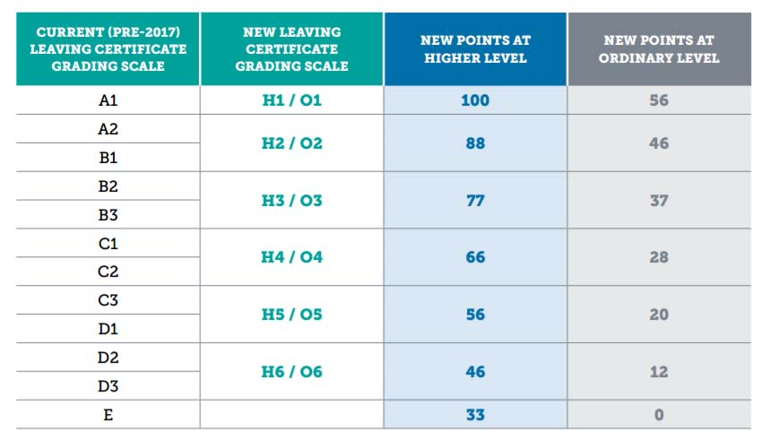

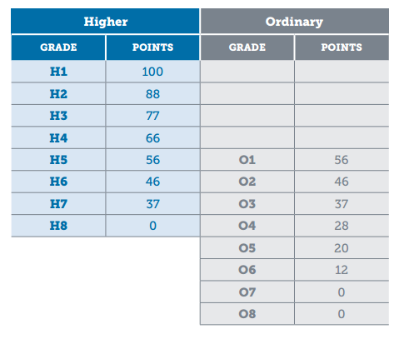

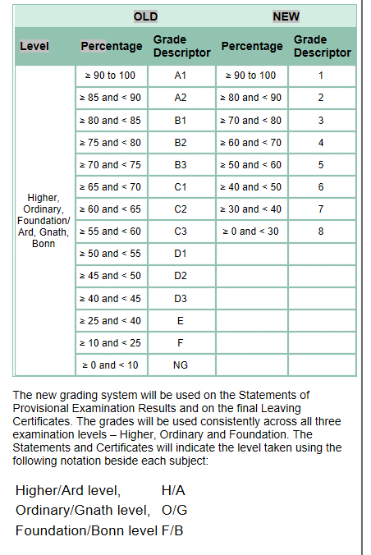

QQI-FET Applicants
A pass in any cognate QQI-FET (formerly FETAC)/QQI Award at Level 5/6 meets the entry requirements for the Higher Certificate or Bachelor Degree (Level 6 or Level 7) programmes.
Applicants to the programme are also required to have required D3 (O6/H7) ordinary level grade in Leaving Certificate Mathematics.

From 2017 the points awarded for QQI-FET awards will also be revised. This is required to maintain the existing equivalence with the current points scale, and reflects the overall marginal reductions in student’s points scores under the new points scale.

Currently the maximum possible total score of 360 (120 credits x 3 for a distinction) is multiplied by 10 and divided by 9 to give a maximum overall points score of 400. From 2017, this maximum possible total score of 360 will be multiplied by 13 and divided by 12, to give a revised maximum overall points score of 390 for applicants from further education and training.

http://www2.cao.ie/fetac/FETAC_scoring.pdf

Mature Students
Applicants who are over 23 years of age on January 1st of the year of entry may gain entry to the programme via the mature applicant route. Acceptance will be based on an interview process to determine previous experiential learning, the student’s suitability to the subject area and their commitment to achieving the minimum intended programme learning outcomes.

Note to Employers: Mature students should be assessed for entry to the programme using the attached Mature Student Assessment Form which must be completed and submitted to GMIT Admissions Office and kept on file by the company.

Minimum English requirements

Non-EU Applicants: Non-EU applicants, who are not English speakers, must have a minimum score of 5.5 in the International English Language Testing System (IELTS), with a minimum of 5 IELTS in each component, or equivalent
EU Applicants: EU applicants, who are not English speakers, are recommended to have a minimum score of 5.5 in the International English Language Testing System (IELTS), with a minimum of 5 IELTS in each component, or equivalent.

Mature Student Assessment Form
Name of Applicant
Address of Applicant
Company
Date of Interview
Interview Panel Member Names

Confirmation that the applicant is a Mature Student, over 23 years of age on January 1st of the year of entry to the programme.
Detail how this is evidenced. _______________________________________________

PERSONAL BACKGROUND
- 1. Appropriateness of Previous Study ______/ 10
- 3. Appropriateness of Work Experience ______/10
- 3. Length of experience and level of achievement ______/10
- 4. Appropriateness of life experience (hobbies,
- expertise, skills etc) ______/10

CAREER OBJECTIVES
- 5. Awareness of objectives and own career goals ______/10
- 6. Knowledge of career choice – manufacturing and
- industry ______/10
- 7. Awareness of demands of third-level study
  - and learning by apprenticeship. ______/10

PERSONAL QUALITIES
- 8. Communication skills ______/10
- 9. Motivation to succeed, and self-confidence ______/10
- 10. Projection of ability to succeed on programme ______/10

Total Score. ______/100

Recommendation: _________________________________________________________________

Reason for low score (if appropriate): _________________________________________________________________

Signature of Panel Members:
______________________ __________________
_______________________ _________________
Notes on completion of the Mature Student Assessment form

The assessment form consists of 10 questions, each equally weighted giving an overall maximum score out of 100.
The Form evaluates the candidate under three sections Personal Background, Career Objectives and Personal Qualities.

The Personal Background section evaluates the candidate’s previous studies, work experience and life experiences and achievement to evaluate the likelihood of success on the apprenticeship programme. This gives the interviewer the
opportunity to evaluate the candidate’s history and track record of achievement across the key background areas.

The Career Objectives section assists in understanding the candidate’s motivation for a career in the area of study and it is expected that the candidate will have done some background research on the industry and would have a knowledge of roles and the company to which s/he is applying.

The Personal Qualities section evaluates the candidate’s communication skills and motivation to complete the programme and based on all the evidence presented the panel score the ability of the candidate to succeed on the programme.
This form provides the evidence that the apprentice was interviewed and assessed based on the entry requirements for mature students:

Mature' applicants (defined as who are over 23 on January 1st of the year of entry), do not require the above minimum entry requirements and acceptance will be based on experiential learning, commitment to course objectives and an interview.

The interview will be used to assess the applicant’s prior learning, and commitment to the course objectives.
Some points to note: -
1. It is an academic programme and applicants will need to be able to demonstrate that they can successfully deal with the competing demands of an academic programme and the workplace.

2. During the Industry Block, the programme will require study outside office/normal working hours. It is anticipated that for the average student that would be 6-10 hours per week. During the Academic Block, it is estimated that students will also have 22 hours of self-study per week, in addition to 28 hours of class contact.

Applicants would need to commit to sustaining this level of workload.

3. It is anticipated that the apprentice will devote themselves fully to the workplace and study and will not engage in other part-time work for the duration of the apprenticeship.

Sample Questions:
- What led to your decision to apply for this programme?
- What aspects of the programme appeal to you?
- What modules/subjects on the course are you most looking forward to?
- How did you find out about it?
- Do you have any hobbies or interests that are relevant to this programme?
- This programme requires skills in mathematics and science. How do you feel your prior experience/employment has prepared you?
- Which of your strengths are most relevant to the programme?
- What will be the most challenging aspects for you of studying to become an engineer, through apprenticeship mode?
- What appeals to you most about becoming a Manufacturing Engineer?
- In this programme, you will need to balance work and studies during your Industry Block. How do you feel you will approach this?

