Minimum Entry Requirements & Assessment of Mature Student Applicants for the Bachelor of Science (Ordinary) in Polymer Processing Technology (Apprenticeship)

1.1 Introduction
This document outlines the entry requirements for the B.Sc. in Polymer Processing Technology Apprenticeship Programme. Included are details of the required Irish Leaving Certificate prior and subsequent to the revised Leaving Certificate grading scale (effective from the June 2017 examination). For the purposes of consistency, QQI recommends adoption of this new grading scale by higher education and training providers of QQI validated programmes.
Also outlined below are the QQI-FET and Mature Applicant entry requirements for the programme.
1.2 Entry Requirements for Irish Leaving Certificate Applicants (From August 2017)
Applicants must have obtained a minimum of five O6 grades in their Leaving Certificate examination results.
These subjects must include;
- Mathematics (Minimum: H7, O6)
- English or Irish (Minimum: H7, O6).

1.3 Entry Requirements for Irish Leaving Certificate Applicants (Prior to August 2017)
The grades of applicants who completed the Leaving Certificate pre-2017 can be mapped directly to a grade on the new grading scale. This mapping exercise for such applicants should be completed so that the entry requirements outlined above can be applied. The grades to be awarded from 2017 for pre-2017 Leaving Certificate grades are set out in the table below.
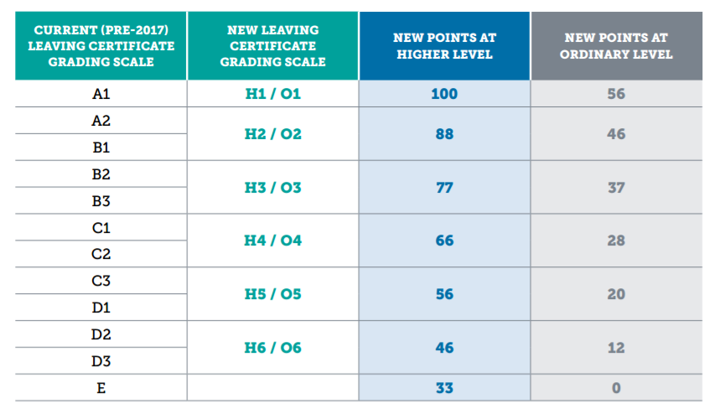

1.4 QQI-FET Applicants
QQI-FET applicants to this programme must hold the following award: Engineering Technology (5M2061). They are also required to have the module Mathematics for Engineering (5N1833) included in their award or alternatively have Leaving Certificate Mathematics.
1.5 Mature Students
Applicants who are over 23 years of age on January 1st of the year of entry may gain entry to the programme via the mature applicant route. Acceptance will be based on an interview process to determine previous experiential learning, the student’s suitability to the subject area and their commitment to achieving the minimum intended programme learning outcomes.
1.5.1 Note to Employers: Mature students should be assessed for entry to the programme using the attached Mature Student Assessment Form which must be completed and submitted to AIT Admissions Office for approval. The completed form should also be kept on file by the company.
1.6 Minimum English requirements
All non-native English speaking applicants must achieve the following standards in the International English Language Testing System (IELTS) or equivalent.
IELTS Academic: 5.5 IELTS Score (minimum of 5 IELTS in each component)
Leaving Certificate English: Grade O6 or H7 will also be acceptable.
Other English language examination results and qualifications may be deemed acceptable and will be considered on a case-by-case basis. The equivalence will be presented to and approved by the programme provider, AIT.

Mature Student Assessment Form
Name of Applicant
Address of Applicant
Applicant Contact No
Company
Date of Interview
Interview Panel Member Names

1.Confirmation that the applicant is a Mature Student, over 23 years of age on January 1st of the year of entry to the programme.
Detail how this is evidenced: ___________________________________________________________________
2.Where applicable (see section 1.6 above), confirmation is required that the applicant has achieved the minimum English language requirements.
Detail (and attach results) how this is evidenced: __________________________________________________
3.Complete out the following assessments of the applicant during their interview process.
PERSONAL BACKGROUND
- Appropriateness of previous study | /10
- Level of achievement | /10
- Appropriateness of work experience | /10
- Length of experience and level of achievement | /10
- Appropriateness of life experience | /10
CAREER OBJECTIVES
- Awareness of objectives | /10
- Knowledge of career choice | /10
PERSONAL QUALITIES
- Communication skills | /10
- Motivation to succeed | /10
- Projection of ability to succeed on programme | /10
TOTAL SCORE | /100

Recommendation: ____________________________________________________________
Signature of Panel Members: ________________________________________
________________________________________
________________________________________
Approved: Employer: ____________________________ Date: _________________
AIT Admissions: ____________________________ Date: _________________
This completed form should be sent to AIT admissions office and kept on file by the employer.

Notes on completion of the Mature Student Assessment form

The applicant must confirm their date of birth and provide proof that they are over 23 years of age on January 1st of the year of entry to the programme.
Non-native English speaking applicants must provide evidence that they have achieved the minimum English language requirements for entry to the programme.
The assessment form consists of 10 questions, each equally weighted giving an overall maximum score out of 100.
The Form evaluates the candidate under three sections Personal Background, Career Objectives and Personal Qualities.
The Personal Background section evaluates the candidate’s previous studies, work experience and life experiences and achievement to evaluate the likelihood of success on the apprenticeship programme. This gives the interviewer the opportunity to evaluate the candidate’s history and track record of achievement across the key background areas.
The career objectives section assists in understanding the candidate’s motivation for a career in the area of study and it is expected that the candidate will have done some background research on the industry and would have a knowledge of roles and the company to which s/he is applying.
The Personal Qualities section evaluates the candidate’s communication skills and motivation to complete the programme and based on all the evidence presented the panel score the ability of the candidate to succeed on the programme.
This form provides the evidence that the apprentice was interviewed and assessed based on the entry requirements for mature students:
Mature' applicants (defined as who are over 23 on January 1st of the year of entry), do not require the above minimum entry requirements and acceptance will be based on experiential learning, commitment to course objectives, proof of achievement of minimum English language requirements and an interview.
The interview will be used to assess the applicant’s prior learning, and commitment to the course objectives.
Some points to note: -
- The B.Sc. in Polymer Processing Technology Apprenticeship is an academic programme and applicants will need to be able to demonstrate that they can successfully deal with the competing demands of an academic programme and the workplace.
- The programme will require study outside office/normal working hours. It is anticipated that for the average student that would be a minimum of 10 hours per week. Applicants would need to commit to sustaining this level of workload.
- It is anticipated that the apprentice will devote themselves fully to the workplace and study and will not engage in other part-time work for the duration of the apprenticeship.

Table taken from New Leaving Certificate Grading Scale and Revised Common Points Scale to be found at http://www.transition.ie/files/2015/FullDetails-RevisedCommonPointsScale.pdf

